

**CONTENTS**

1. Certificate 1
2. Certificate of approval 2
3. Declaration 3
4. Acknowledgement 4
5. Objective & Scope of the Project 6
6. Theoretical Background 8
7. Definition of Problem 21
8. System Analysis & User Requirements 22
9. System Planning (PERT Chart) 23
10. Methodology adopted, System Implementation & Details of H/W& S/W used 25
11. Detailed Life Cycle of the Project 26
12. ERD, DFD 29
13. Process involved, Algorithm, Flowchart, Database diagram 32
14. Input and Output Screen Design(Snapshots) 39
15. Methodology used for testing 56
16. User/Operational Manual (security aspects, access rights, back up, controls, etc.) 58
17. Future enhancement 60
18. Conclusions 61
19. references 63

**1. Objective & Scope**

## 1.1 Objective

This is a web oriented application allows us to access the whole information about the college, staffs, students, facilities etc. This application provides a virtual tour of Campus. Here we will get the latest information about the students and staffs. This generic application designed for assisting the students of an institute regarding information on the courses, subjects, classes, assignments, grades and timetable. It also provides support that a faculty can also check about his daily schedule, can upload assignments, and notices to the students. Here administrator will manage the accounts of the student and faculties, makes the timetable, and upload the latest information about the campus.

## 1.2 Scope

* College information: Through this service one can access the complete information about the college campus such as courses available, admission procedure, placements, college events, achievements etc.
* Student tracking: Any company or any organization that want to check the summary about the student of the college, so that they will be able to choose the particular students for their campus placement And for that purpose they will be given a particular link through which they can access the information required.
* Student attendance status: It gives the attendance status of students. Faculty will update the attendance periodically and can be seen by students and parents.
* Student’s performance in exams: This facility provides the performance of the student in each exam which is conducted by university or college such as midterm performance. Marks obtained by students in exams will be updated by faculties that can be access by students and parents.
* Exam Notification: This facility notifies students and parents about examination schedule.
* Events: It will give information about different events that will be conducted by college time to time. Information about these events will be updated by administrator.
* Online assignments: This service provides the facility to faculty to upload assignments and to students to submit these assignments online.
* Information about staff: It will help in maintaining complete information about college faculty members such as their department, cadre, date of joining, salary, etc. Administrator will register new faculties and remove their account when they leave the college.

**2. Theoretical Background**

Today in colleges student details are entered manually. The student details in separate records are tedious task. Referring to all these records and updating is needed. There is a chance for more manual errors.

**Problems in existing system:**

* It was limited to a single system.
* It was less user-friendly.
* It have a lots of manual work (Manual system does not mean that we are working with pen and paper, it also include working on spread sheets and other simple software's)
* It requires more no of employees need to work.
* It was time consuming process.
* The present system was very less secure.
* It is unable to generate different kinds of report.

**Solution to these problems:**

The development of the new system contains the following activities, which try to automate the entire process keeping in view of the database integration approach.

* User friendliness is provided in the application with various controls.
* The system makes the overall project management much easier and flexible.
* It can be accessed over the Internet.
* Various classes have been used to provide file upload and mail features.
* There is no risk of data mismanagement at any level while the project development is under process.
* It provides high level of security using different protocols like https etc.

**3. Problem Definition**

The problem is to provide the complete information about the college campus. In which the college staff members, students and parents can access the information and will be familiar with college campus. It will provide interactive environment for the staff, students and parents by getting knowledge of student attendance, remarks, exams performances, grades, timetables, notices etc.

**4. System analysis & planning v/s user requirement**

**4.1 User requirements:**

The following requirements are raised during the analysis of the needs of the users:

* A Person Should be able to login to the system through the first page of the Application.
* The Administrator can create users as per user requirement.
* Admin can upload the data for a particular Student. On successful completion of upload, user (Student/Parent/Faculty) can view reports.
* A general user will have access to see the status of particular Student id number.
* Student (user) can use all the facilities, same as which are provided to him in the college.
* Student can see attendance, notices, grades, report and other facilities in updated manner.
* There will be a separate page for every student as his account in which he can get notices, attendance, grades, assignments etc.
* Parent can just view the record of student with the username and password provided.
* Faculty can give the attendances and notices for the students.
* The administrator verifies all these reports and generates them for users to view them.

After analyzing the requirements of the task to be performed, the next step is to analyze the problem and understand its context. The first activity in the phase is studying the existing system and other is to understand the requirements and domain of the new system. Both the activities are equally important, but the first activity serves as a basis of giving the functional specifications and then successful design of the proposed system. Understanding the properties and requirements of a new system is more difficult and requires creative thinking and understanding of existing running system is also difficult, improper understanding of present system can lead diversion from solution.

**4.2 Analysis Model**

This document play a vital role in the development of life cycle (SDLC) as it describes the complete requirement of the system. It means for use by developers and will be the basic during testing phase. Any changes made to the requirements in the future will have to go through formal change approval process.

SPIRAL MODEL was defined by Barry Boehm in his 1988 article, “A spiral Model of Software Development and Enhancement. This model was not the first model to discuss iterative development, but it was the first model to explain why the iteration models.

As originally envisioned, the iterations were typically 6 months to 2 years long. Each phase starts with a design goal and ends with a client reviewing the progress thus far. Analysis and engineering efforts are applied at each phase of the project, with an eye toward the end goal of the project.

The steps for Spiral Model can be generalized as follows:

* The new system requirements are defined in as much details as possible. This usually involves interviewing a number of users representing all the external or internal users and other aspects of the existing system.
* A preliminary design is created for the new system.
* A first prototype of the new system is constructed from the preliminary design. This is usually a scaled-down system, and represents an approximation of the characteristics of the final product.
* A second prototype is evolved by a fourfold procedure:

1. Evaluating the first prototype in terms of its strengths, weakness, and risks.
2. Defining the requirements of the second prototype.
3. Planning and designing the second prototype.
4. Constructing and testing the second prototype.

* At the customer option, the entire project can be aborted if the risk is deemed too great. Risk factors might involved development cost overruns, operating-cost miscalculation, or any other factor that could, in the customer’s judgment, result in a less-than-satisfactory final product.
* The existing prototype is evaluated in the same manner as was the previous prototype, and if necessary, another prototype is developed from it according to the fourfold procedure outlined above.
* The preceding steps are iterated until the customer is satisfied that the refined prototype represents the final product desired.
* The final system is constructed, based on the refined prototype.
* The final system is thoroughly evaluated and tested. Routine maintenance is carried on a continuing basis to prevent large scale failures and to minimize down time.

The following diagram shows how a spiral model acts like:

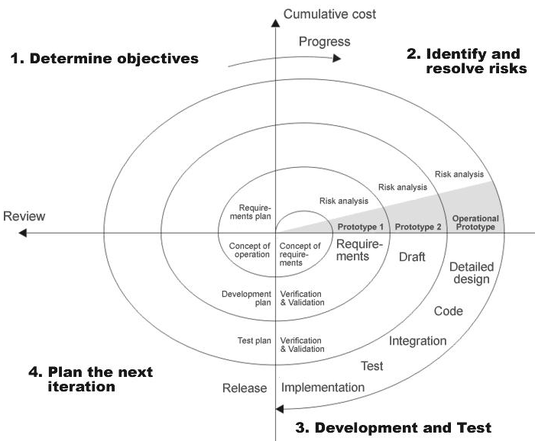

**4.3 Study of the System:**

**4.3.1 Graphical user interface**

In the flexibility of the uses the interface has been developed a graphics concept in mind, associated through a browses interface. The GUI’S at the top level have been categorized as

1. Administrative user interface
2. The operational or generic user interface

The administrative user interface concentrates on the consistent information that is practically, part of the organizational activities and which needs proper authentication for the data collection. The interfaces help the administrations with all the transactional states like Data insertion, Data deletion and Date updation along with the extensive data search capabilities.

The operational or generic user interface helps the users upon the system in transactions through the existing data and required services. The operational user interface also helps the ordinary users in managing their own information helps the ordinary users in managing their own information in a customized manner as per the assisted flexibilities.

# 4.4 Number of Modules

The system after careful analysis has been identified to be presented with the following modules:

The modules involved are:

1. College information: Through this service one can access the complete information about the college campus such as courses available, admission procedure, placements, college events, achievements etc.
2. Student tracking: Any company or any organization that want to check the summary about the student of the college, so that they will be able to choose the particular students for their campus placement And for that purpose they will be given a particular link through which they can access the information required.

1. Student attendance status: It gives the attendance status of students. Faculty will update the attendance periodically and can be seen by students and parents.
2. Student’s performance in exams: This facility provides the performance of the student in each exam which is conducted by university or college such as midterm performance. Marks obtained by students in exams will be updated by faculties that can be access by students and parents.
3. Exam Notification: This facility notifies students and parents about examination schedule.
4. Events: it will give information about different events that will be conducted by college time to time. Information about these events will be updated by administrator.
5. Online assignments: This service provides the facility to faculty to upload assignments and to students to submit these assignments online.
6. Information about staff: It will help in maintaining complete information about college faculty members such as their department, cadre, date of joining, salary, etc. Administrator will register new faculties and remove their account when they leave the college.
7. **Requirement analysis and proposed design**

**5.1 Feasibility studies**

Perform and evaluate feasibility studies like cost-benefit analysis, technical feasibility, time feasibility and operational feasibility for the project. Project Scheduling should be made using PERT charts.

Feasibility study is carried out to decide whether the proposed system is feasible for the company. The feasibility study is to serve as a decision document it must answer three key questions:

1. Is there a new and better way to do the job that will benefit the user?
2. What are the cost and the savings of the alternative(s)?
3. What is recommended?
4. **Technical feasibility:**

Our System will be an online mobile and web based system. Since internet, web browsers and web hosting are easily available, the application will be easy to host and access. Tools and technologies like Sublime, MySQL database, Xampp, are open source so it will not be difficulty in developing the system.

1. **Economical feasibility:**

Economical Feasibility is the most frequently used method for evaluating the effectiveness of a candidate system. More commonly known as Cost/ Benefit analysis, the procedure is to determine the benefits and savings that are expected from the candidate system and compare them with costs. If the benefits outweigh costs, then the decision is made to design and implement the system.

1. **Operational Feasibility :**

Our system requires timely update over the extracted data to provide the user with the consistent and reliable information. It is easier to manage. No extra hardware other than a computer is necessary for developing and running the website.

5.2 **Non- Functional Requirement**

* **Accuracy**:The data displayed by the website shall be accurate, consistent and timely updated.
* **User Friendly:** The system shall be interactive and easy to use. It shall have nice interface that will attract the students. All the important information about the college shall be easily accessible and clearly visible to the students.
* **Performance:** The system shall be fast. It shall provide all queries of students.

# 8. Use Case Diagram of System

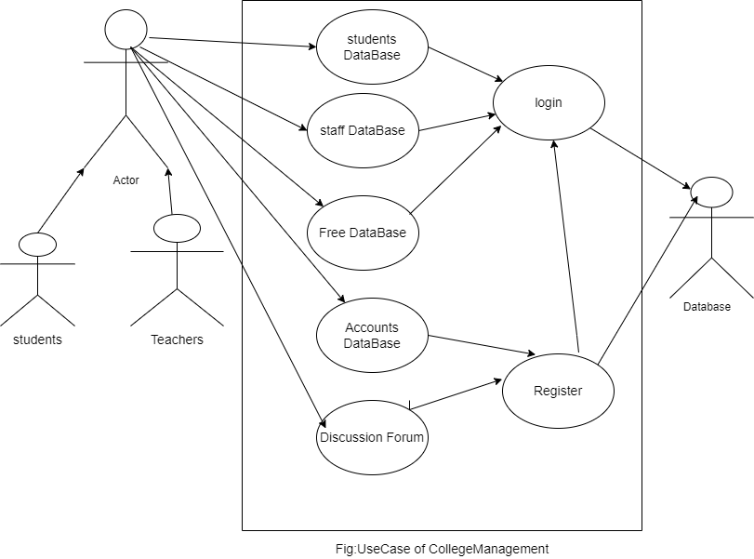

**6. Methodology Adopted, System Implementation & Details of Hardware & Software Used**

**6.1 Methodology adopted and System implementation:**

1. Apache tomcat is used as a web server to host the application.
2. All the environment variables are set.
3. The application is pasted in the webapps folder.
4. Web server is started now.
5. Application is run using the web browser by typing http://localhost/cis
6. Web.xml file is used to control the flow and user actions.
7. **DETAILED LIFE CYCLE OF PROJECT**

We have used Waterfall Model as Software Engineering life Cycle Process. It is the simplest; oldest and most widely used process model for software development .This model acquires its name from the fact that classic software life cycle is represented as a sequence of descending steps.

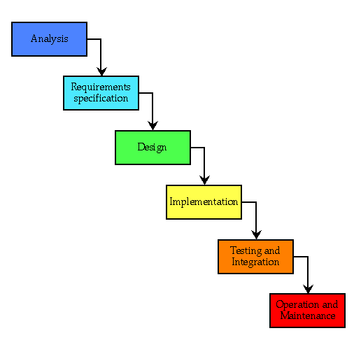

**7.1 Requirement Analysis:**

This process is also known as feasibility study. In this phase, the development team studied the site requirement. They investigate the need for possible dynamic representation of the site and increase security features. By the end of feasibility study, the team furnishes a document that holds the different specific recommendations for the candidate system. It also includes personnel assignments, costs, project schedules, target dates etc. the requirement gathering process is intensified and focused specially on software. The essential purpose of this phase is to find the need and to define the problem that needs to be solved. During this phase following facts were gathered.

* Determined the user need
* Identified the facts
* Establish the goals and objective for the proposed system
* Feasibility for the new system

**7.2 System Analysis and Design:**

In this phase the software’s overall structure and its nuances are defined. In terms of client server technology the no of tiers needed for the package architecture, database design, data structure design etc are defined in this phase. Analysis and Design are very crucial in entire development cycle. Any glitch in this phase could be expensive to solve in the later stage of software development. Hence following is the essential approach taken during website designing:

* DFD
* Database Designing
* Form Designing
* Pseudo code for methods

**7.3 Testing:**

Once the code is generated, the website testing begins. Different testing methodologies are done to unravel the bugs that were committed during the previous phases. Different testing methodologies are used:

* Acceptance testing
* White Box Testing
* Black Box Testing

1. **ER-Diagram and Data Flow Diagram**
   1. **ER-Diagram:-**

**8.2.2 Login DFD Diagram:**



**8.2.3 Admin Details Data Flow:**

**1st level DFD:**

Students info

Login

Enter details

Update

**2nd Level DFD**

Id

Login

Login

Enter details

Student table

Modify

Student Student table

Faculty info.

Notification

**8.2.4 Student Details Data Flow**

**1st level DFD**

Student’s info

Login

Enter details

Update

**2nd level DFD**

Grades

Notices

Attendance

View marks

Id

Login

Login

Student table

Query

Submission

Faculty

Feed back

Mgmt.

* 1. **Database Design:-**

1. **Input and Output Screen Design (Snapshots)**

**10. Methodology used for testing**

The completion of a system will be achieved only after it has been thoroughly tested. Though this gives a feel the project is completed, there cannot be any project without going through this stage. Hence in this stage it is decided whether the project can undergo the real time environment execution without any break downs, therefore a package can be rejected even at this stage.

**10.1 Testing methods**

Software testing methods are traditionally divided into black box testing and white box testing. These two approaches are used to describe the point of view that a test engineer takes when designing test cases.

1. **Black box testing** - Black box testing treats the software as a "black box," without any knowledge of internal implementation. Black box testing methods include: equivalence partitioning, boundary value analysis, all-pairs testing, fuzz testing, model-based testing, traceability matrix, exploratory testing and specification-based testing.
2. **White box testing** - White box testing, by contrast to black box testing, is when the tester has access to the internal data structures and algorithms (and the code that implement these).White box testing methods can also be used to evaluate the completeness of a test suite that was created with black box testing methods. This allows the software team to examine parts of a system that are rarely tested and ensures that the most important function points have been tested.
3. **Grey Box Testing** - Grey box testing involves having access to internal data structures and algorithms for purposes of designing the test cases, but testing at the user, or black-box level. Manipulating input data and formatting output do not qualify as "grey box," because the input and output are clearly outside of the "black-box" that we are calling the system under test. This distinction is particularly important when conducting integration testing between two modules of code written by two different developers, where only the interfaces are exposed for test. Grey box testing may also include reverse engineering to determine, for instance, boundary values or error messages.

### Acceptance testing - Acceptance testing can mean one of two things:

1. A smoke test is used as an acceptance test prior to introducing a build to the main testing process.
2. Acceptance testing performed by the customer is known as user acceptance testing (UAT).

### Regression Testing - Regression testing is any type of **software testing** that seeks to uncover software regressions. Such regression occurs whenever software functionality that was previously working correctly stops working as intended. Typically regressions occur as an unintended consequence of program changes. Common methods of regression testing include re-running previously run tests and checking whether previously fixed faults have re-emerged.

### Non Functional Software Testing - Special methods exist to test non-functional aspects of software.

* Performance testing checks to see if the software can handle large quantities of data or users. This is generally referred to as software scalability. This activity of Non Functional Software Testing is often times referred to as Load Testing.
* Stability testing checks to see if the software can continuously function well in or above an acceptable period. This activity of Non Functional Software Testing is often times referred to as indurations test.
* Usability testing is needed to check if the user interface is easy to use and understand.
* Security testing is essential for software which processes confidential data and to prevent system intrusion by hackers.
* Internationalization and localization is needed to test these aspects of software, for which a pseudo localization method can be used.

**11. User/Operational Manual - Including SECURITY ASPECTS, ACCESS RIGHTS, BACK UP, CONTROLS, etc.**

**12. Future Enhancements**

**13. Conclusion**

**14. References**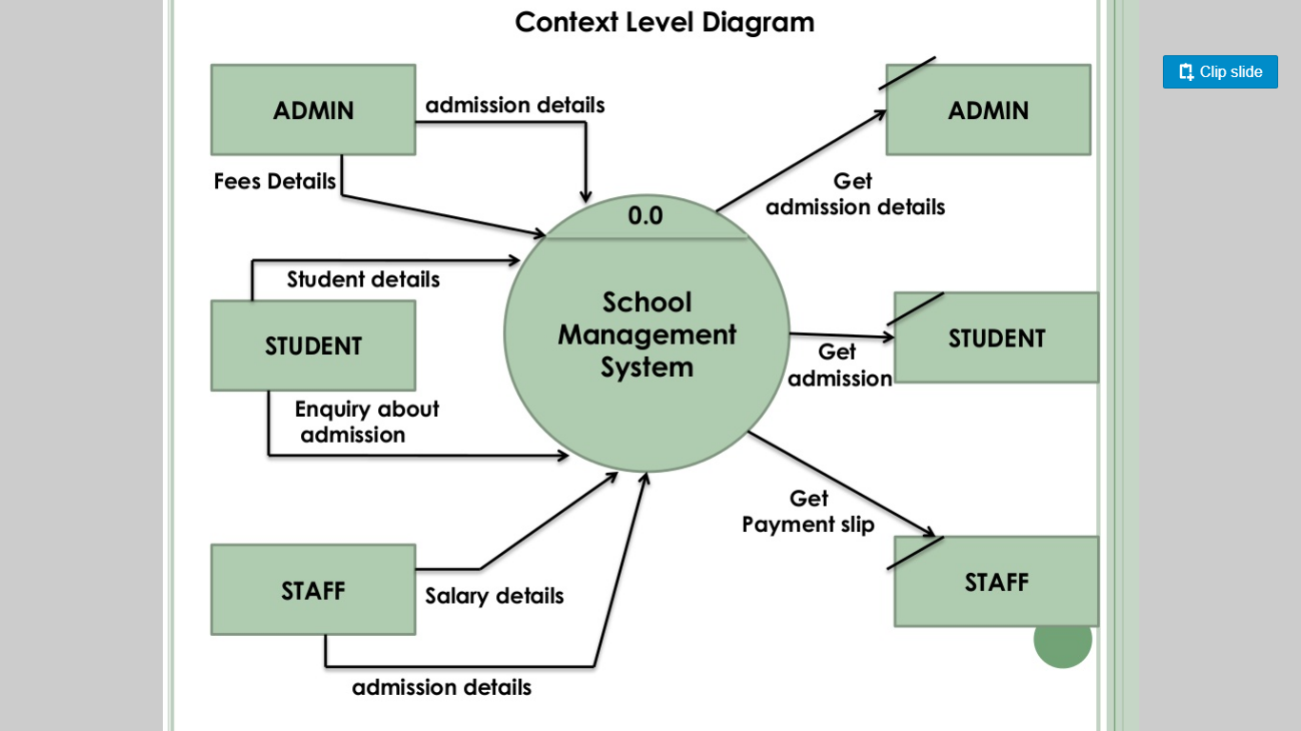

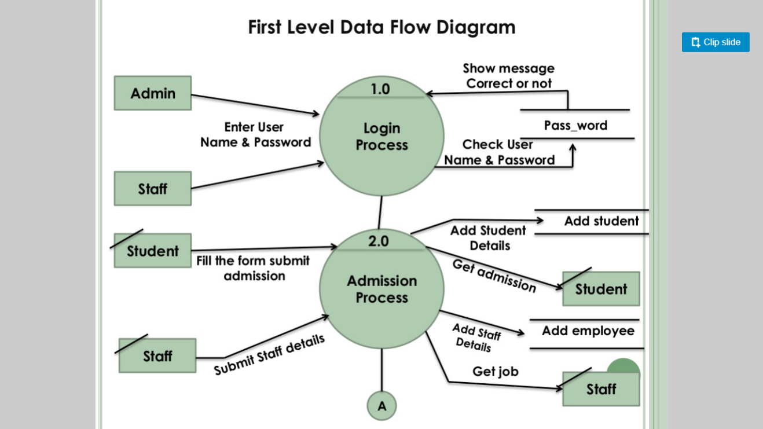

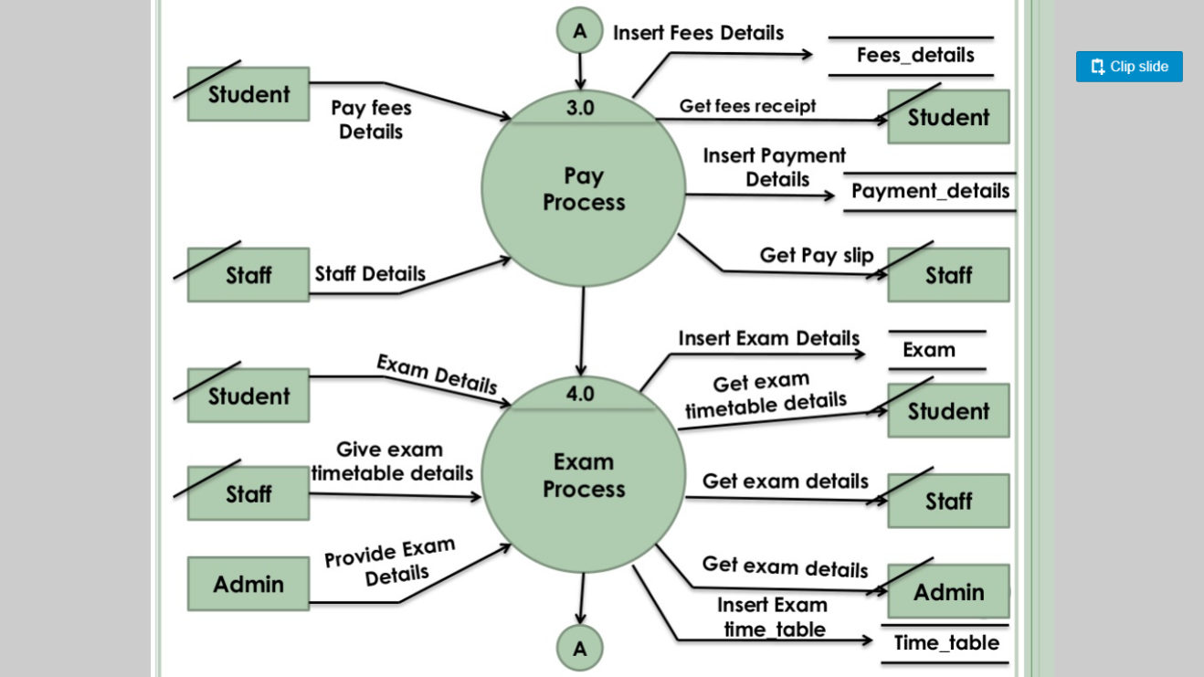



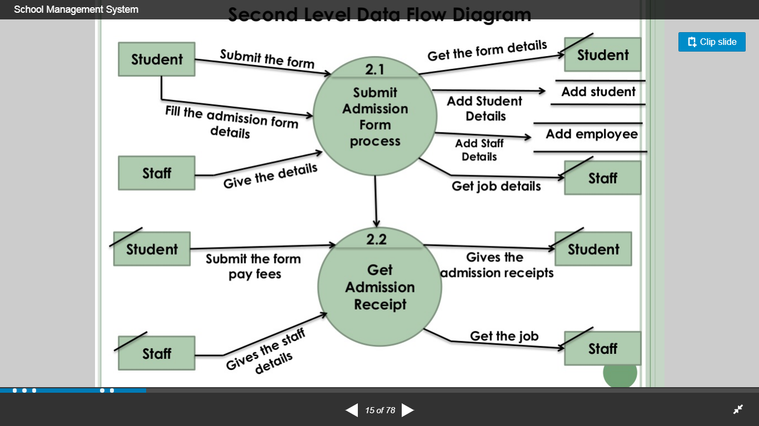

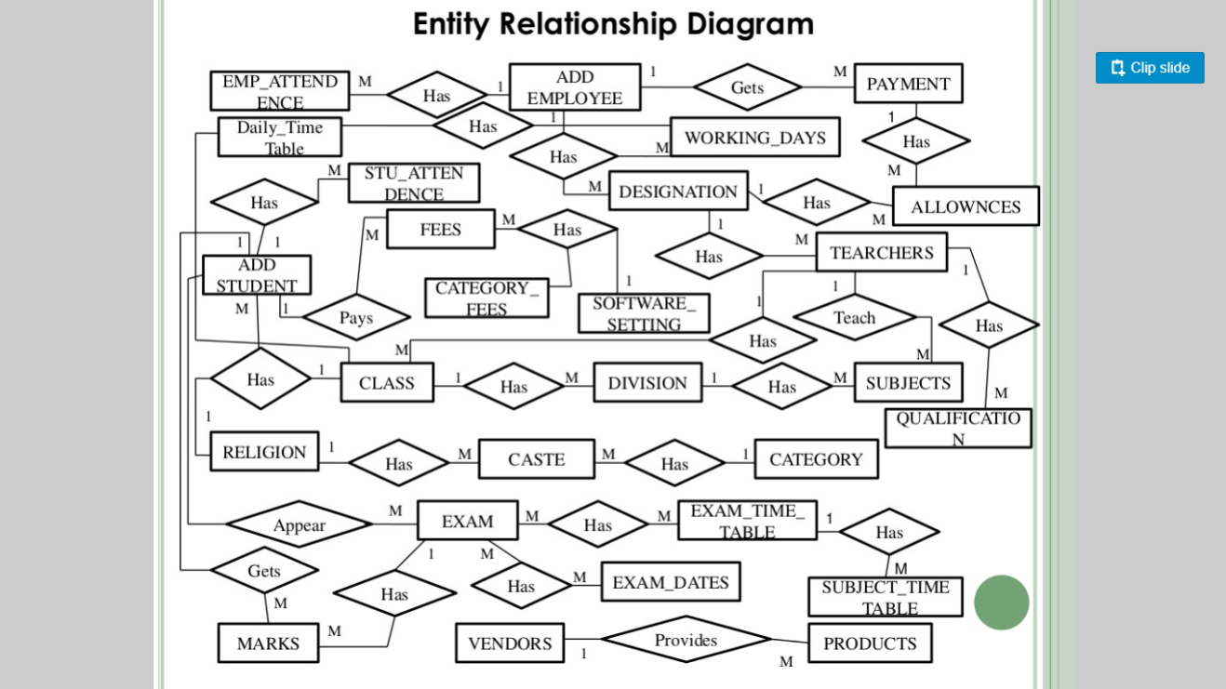

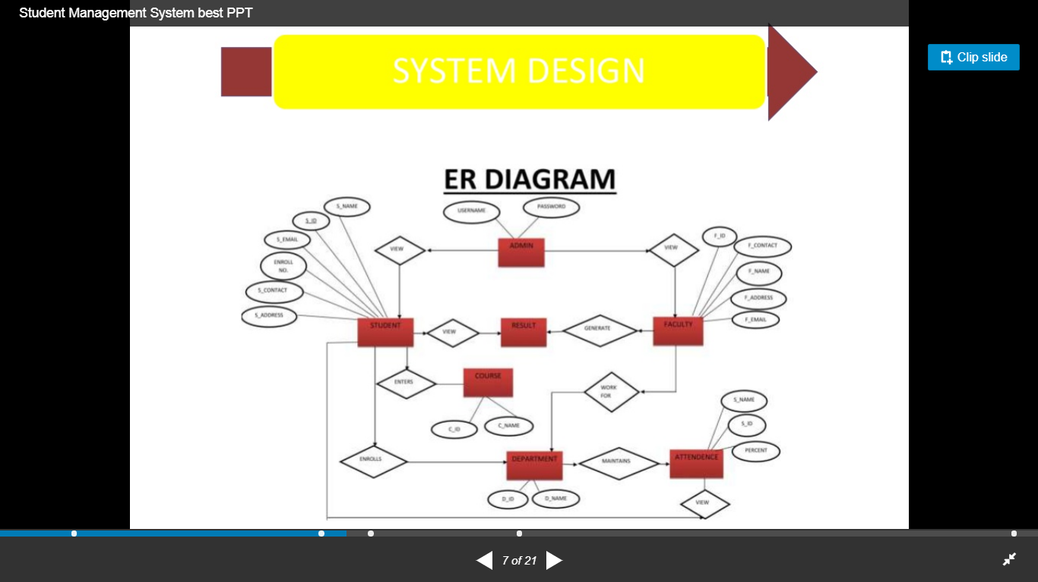

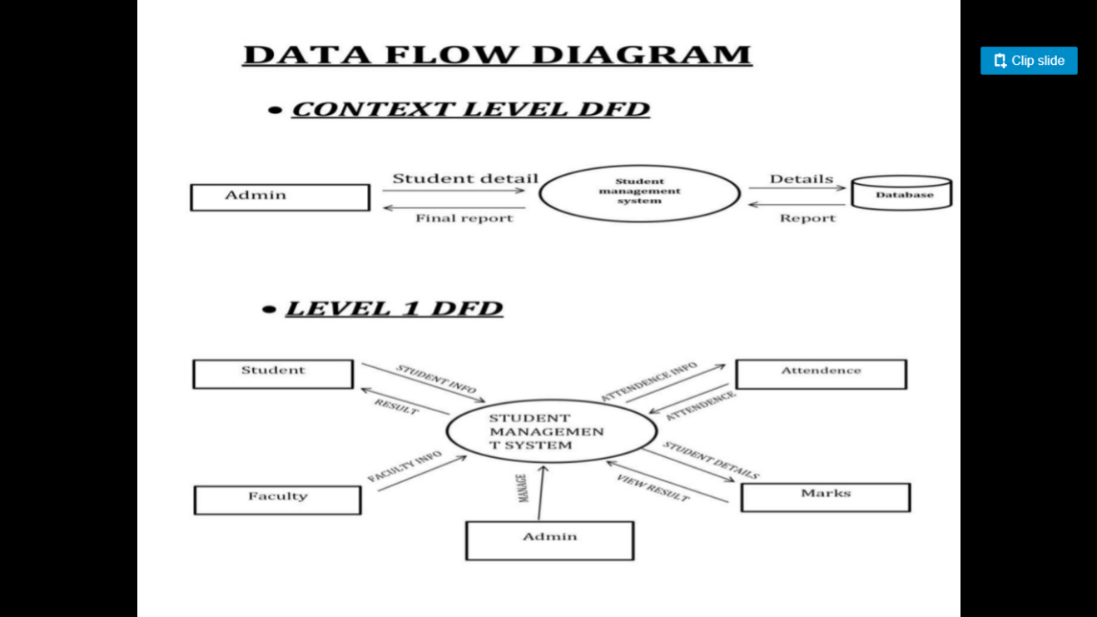

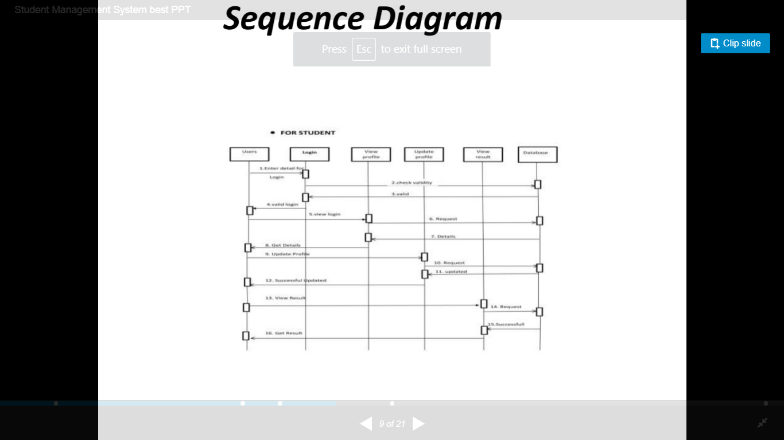

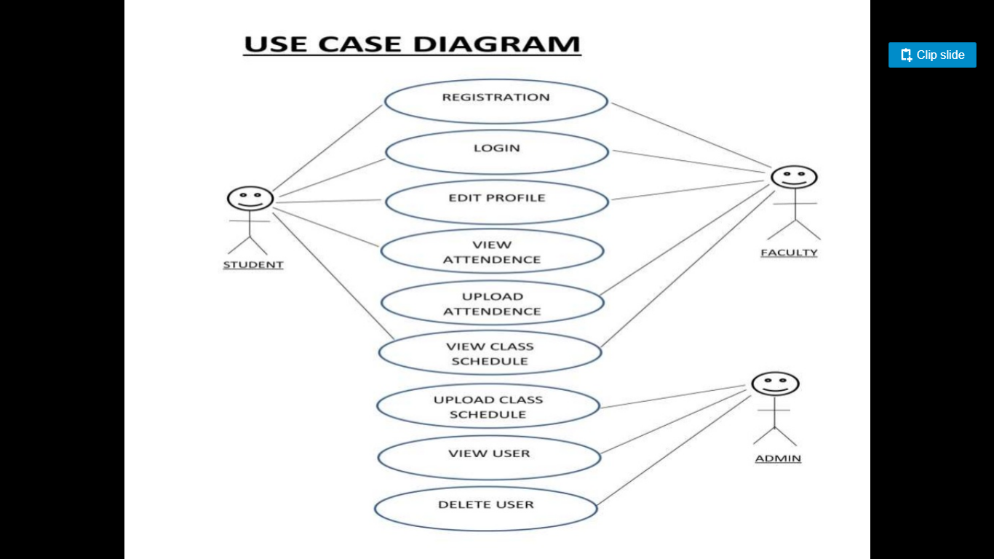

**z**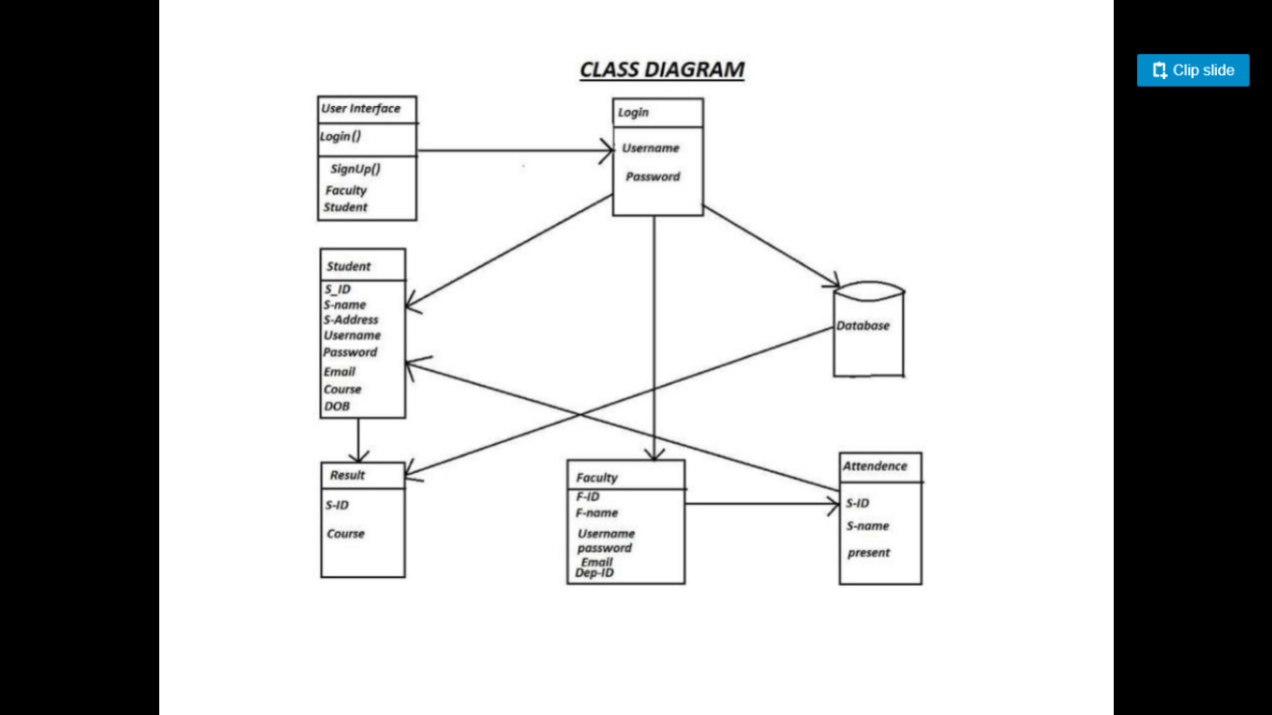

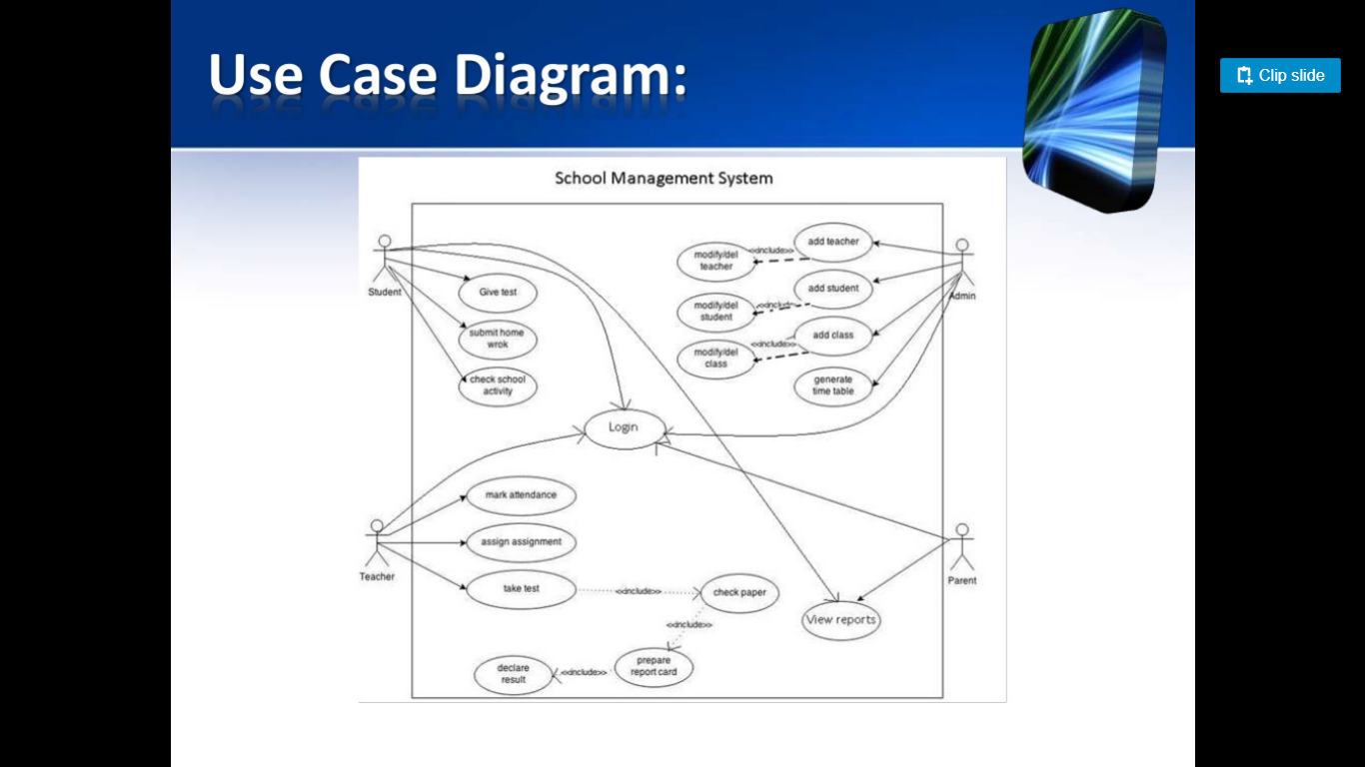

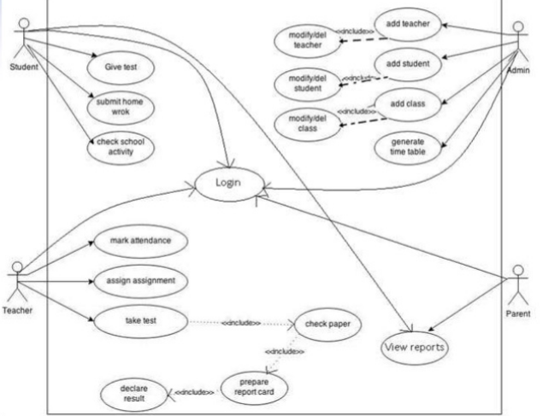

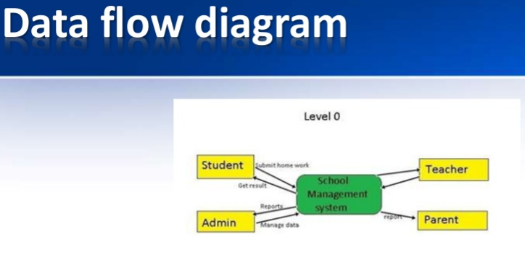

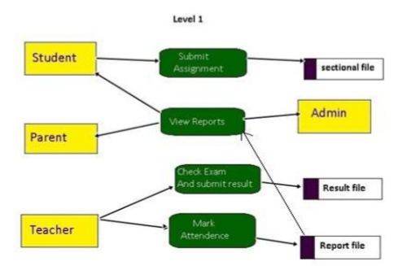

**Class Diagram:**

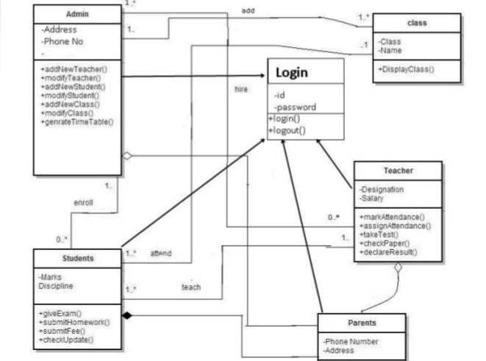



**Sequence dia:**

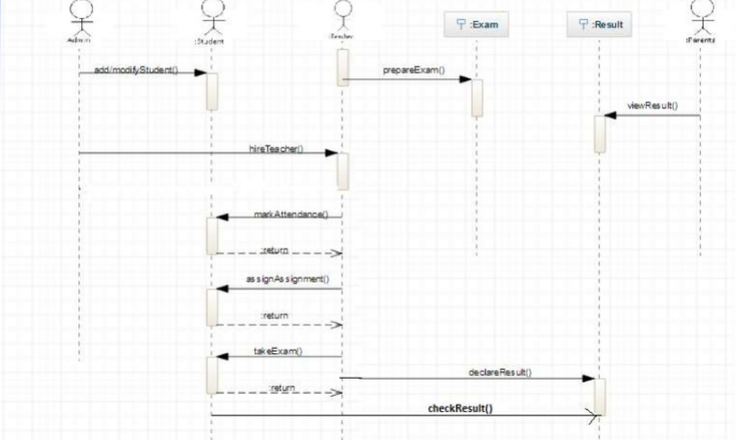

**ERD:**

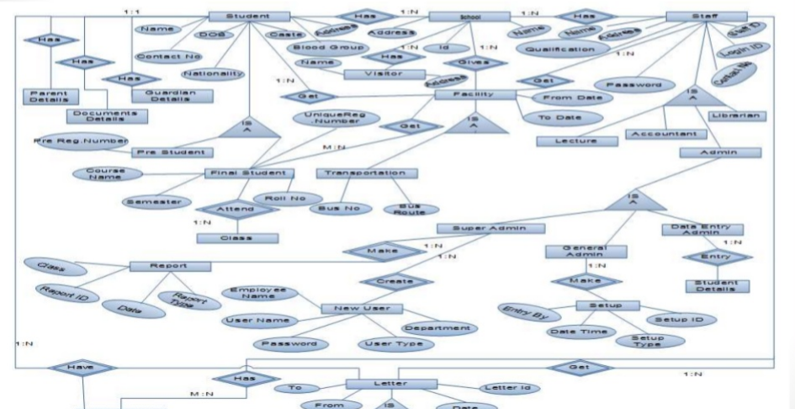

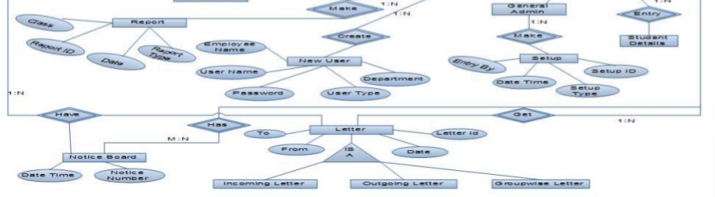

**Class Dia:**

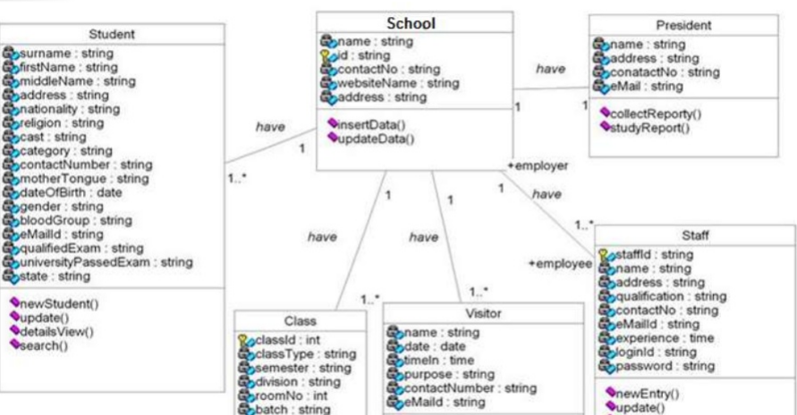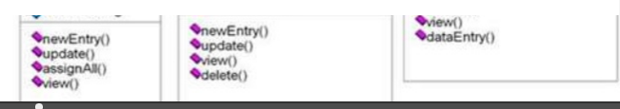

**Activity Diagram:**

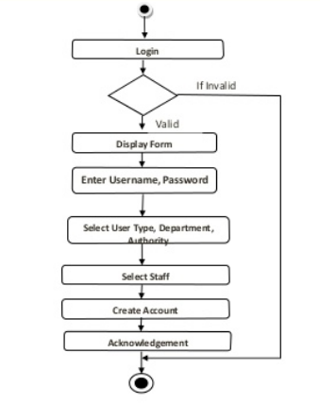

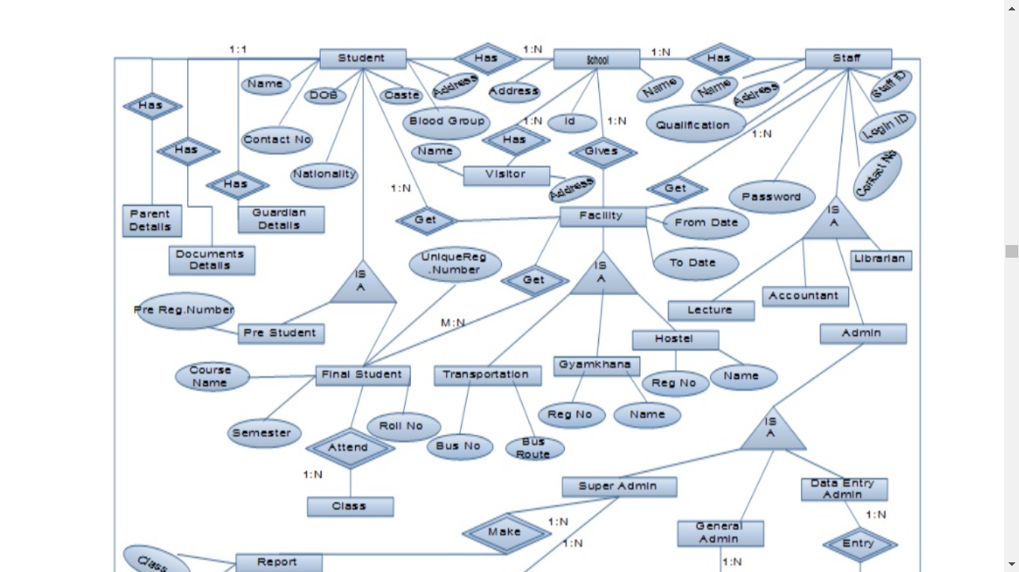

**Feasibility Study:**

## 11. References

[1]. Baba, Y. (n.d.). Retrieved from https://www.yahoobaba.net/php/php-mysqli-fetch-functions

[2]. iyer, m. (n.d.). Retrieved from How To Connect A Signup Form With Database: https://www.c-sharpcorner.com/Blogs/how-to-connect-a-signup-form-with-database

[3]. sinha, K. (n.d.). Retrieved from Create An HTML Form And Insert Data Into The Database Using PHP: https://www.c-sharpcorner.com/UploadFile/52bd60/create-an-html-form-and-insert-data-into-database162/

[4]. TECHI4YOU. (n.d.). *School Website HTML Tutorial with Project*. Retrieved from https://techi4you.com/f/d/fileTAF5MZQP84